Behind-the-Wheel Practice Drives
for Teens
in Driver Education
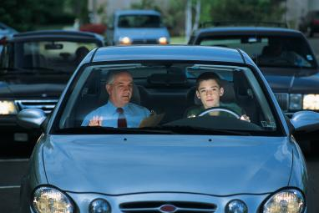
Instructor ____________________________________________
School________________________________________________

Student Driver ________________________________________
To parents, guardians and other supervising adults: HOW TO USE THIS GUIDE
This Behind-the-Wheel (BTW) booklet is intended to foster communication between you and the instructor so you can help your teen make the most of their driver education training.
After completing each of the12 drives with the Driver Education instructor, your teen will bring this guide home to discuss the in-car lessons with you. The instructor will mark the maneuvers (such as “backing up”) that were successfully performed and those that require more practice to master.
Please initial the page each time your teen has discussed a BTW drive with you and make sure they keep this guide with them for the next drive with their instructor.
If your teen has a Learner License, you can use this booklet to plan your practice drives and begin the 50 hours of required supervised practice for Graduated Driver Licensing (GDL).
How to contact your Driver Education Instructor:
Name: __________________________________________________
Work phone: _____________________________________________
Home phone: ____________________________________________
Cell phone: ______________________________________________
Email address: ___________________________________________
For driving times and other driver education information, check the schedule and school website at:
________________________________________________________
Remember: Driving is a privilege, not a right. You earn the right to drive by being cautious and courteous. Be a defensive driver and watch out for the other guy.
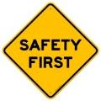
DRIVING RULES

- You must have your TELL permit and a parent or guardian with you when you practice driving.
- Always listen to the instructor. STOP! means STOP.
- Do not distract the driver. NO horseplay by the passengers.
- Conversation must be appropriate. NO rude comments about other drivers.
- We will start and finish at the assigned area at the school. Parents are encouraged to be there 5 minutes early when dropping off and before picking up students.
- Treat the car as if it were your own. Keep it clean and respect it.
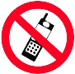
- Ask first to use your cell phone. Texting is NOT allowed on the drives.

6 Helpful Tips for Parents

- When you drive, set a good example for your teenager to imitate. They model you and your driving habits. Always wear your seat belt, and drive rested and undistracted.
- Plan your driving sessions to be short but frequent, and know what you are going to practice. Plan a stretch break after 30 minutes.
- PATIENCE is the name of the game. Be calm and relaxed to instill confidence in your teen. Yelling or scolding only makes them more nervous than they already are.
- Do not assume your teenager knows what you want them to do. Have a plan and route for the lesson before you start out.
- While driving, give directions well in advance of the maneuver, so there is time to think and act. (example: At the next corner, turn right)
- Visit the OPI’s Traffic Education web page for additional resources on driving with your teen. (http://opi.mt.gov/Families-Students/Family-Student-Support/Driver-Education.
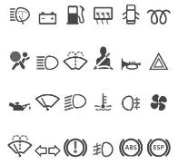
BTW 1
CAR INTRODUCTION,
PART 1
- Seat adjustment
- Speedometer
- Foot brake
- Odometer
- Gas pedal
TECHNIQUES:
- Seat & Mirror Adjustment
- Seat belts (everyone in the car)
- Starting vehicle properly
- Hand location on steering wheel at 9 & 3
- Proper steering at corners
- Maintaining proper lane position
- Ease into acceleration
- Ease into braking stops
- Right turns
- Left turns
- Proper stopping distance

- Alternator light or gauge
- Gear shift lever
- Oil pressure light or gauge
- Temperature light or gauge
- Fuel gauge
- Horn
- Dimmer switch
- Ignition switch
- Turn signal
- Emergency Flasher
- Light switch
- Temperature controls
- Windshield wiper switch
- Safety belts
- Head restraints
- Parking brake
KEYS Activity: Rapid Fire
Teen sits in driver seat (ignition on/engine off) while parent rapidly names vehicle controls. Teen quickly locates each one. Try finding controls blindfolded.
- Oil dip stick
- Brake fluid check
- Windshield washer
- Coolant tank
- Spare tire and jack

INSTRUCTOR INITIALS __________ PARENT/GUARDIAN INITIALS __________
BTW 2
CAR INTRODUCTION, PART 2
OBJECTIVE: The student will be able to demonstrate correct lane position while traveling through residential neighborhoods. The student will be able to identify regulatory signs, control signals, and correct procedure when approaching both controlled and uncontrolled intersections.
RIGHT OF WAY
- Never assume you have the right of way.
- Yield to all emergency vehicles.
- Yield to sight-impaired or blind people.
- Yield to all pedestrians at crosswalks.

TRACKING AND LANE POSITION
- Residential lane position
- Proper care when approaching uncontrolled intersections
- Yielding to all vehicles at uncontrolled intersections
- Signaling with proper distance
- Right turn lane position
- Left turn lane position

INSTRUCTOR INITIALS __________ PARENT/GUARDIAN INITIALS __________
BTW 3
PARKING AND REFERENCE POINTS
BACKING UP USING MIRRORS
OBJECTIVE: The student will be able to successfully park the vehicle in perpendicular fashion and use angle parking. Student will successfully demonstrate backing the car safely using mirrors, looking over the shoulder and controlling the vehicle in a safe manner. The student will be able to utilize reference points to determine the placement of the vehicle.

TIPS FOR THE NEW DRIVER: DO NOT PARK IN A SPACE NEXT TO A POORLY PARKED VEHICLE. IT WILL BE HARDER FOR YOU TO MANEUVER AND YOU WILL NOT BE ABLE TO USE YOUR REFERENCE POINTS.

TECHNIQUE:
- Signal / Mirror / Over-the-shoulder / Go (SMOG)
- Understanding reference points for parking
- Front reference point
- Rear reference point
- Using the curb up front
- Parking up hill
- Parking down hill
- Parking parallel to a curb
- Backing up using mirrors

INSTRUCTOR INITIALS __________ PARENT/GUARDIAN INITIALS __________
BTW 4
ONE WAYS AND LANE CHANGES, PART 1
OBJECTIVE: The student will be able to drive in the correct lane, show proper tracking technique, and be able to determine which lane to turn into and the correct procedure for doing this. Students will define some inherent dangers while driving on one-way streets. Students will be able to perform a safe lane change.

TECHNIQUE:
- SMOG every time
- Turning into the closest lane
- Maintain lane position
- Check mirrors frequently
- Maintain safe speed in residential area

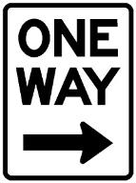

INSTRUCTOR INITIALS __________ PARENT/GUARDIAN INITIALS __________
BTW 5
ONE WAYS AND LANE CHANGES, PART 2

OBJECTIVE: The student will be able to change lanes safely. Students will continue to demonstrate the proper Signal / Mirror / Over-the-shoulder / Go (SMOG) technique.

TECHNIQUE:
- Using SMOG technique
- Maintaining speed on lane change
- Maintaining speed
- Maintaining lane position
- Turning into the nearest lane onto a one-way
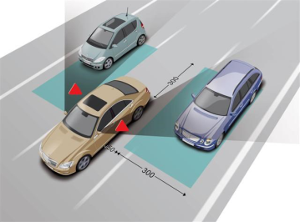
- Making lane change early

INSTRUCTOR INITIALS __________ PARENT/GUARDIAN INITIALS __________
BTW 6
RURAL DRIVING

OBJECTIVE: The student will be able to define open roadway or secondary highway and understand the characteristics. Student will demonstrate appropriate speed, lane positioning and tracking. Student will scan effectively for traffic signs and extend their visual search pattern down the road to 12 seconds.

SAFE DRIVING TIP: KEEPING YOUR LIGHTS ON DURING THE DAY WILL INCREASE YOUR VISIBILITY TO OTHER DRIVERS.

TECHNIQUE:
- Safe speeds
- Posted speed
- Scanning and identifying hazards
- Maintaining lane position

Passing on a two-lane highway is one of the most dangerous maneuvers you will ever do with a vehicle.

INSTRUCTOR INITIALS __________ PARENT/GUARDIAN INITIALS __________
BTW 7
FREEWAY DRIVING

OBJECTIVE: The student will be able to understand the interstate system, rules which govern the controlled access system, merging and correct lane positioning. Student will be able to maintain proper distance from other vehicles and follow required speed limits.

THE INTERSTATE HIGHWAY
- Entrance.
- Acceleration lane.
- Merging with traffic

APPLYING THE FIND-SOLVE-CONTROL PROCESS
- Identify the green guide signs for the exit
- Anticipate and predict actions of other drivers
- Decide on a safe exit speed

STEPS WHEN EXITING
- Half mile to exit – check zones
- Signal and move into lane position
- Move into deceleration zone
- Tap brakes to warn other drivers of intentions
- Identify exit ramp speed

INTERSTATE TRAVEL
- Drive in the correct lane
- Create safety margin in front and behind you
- Drive with the flow of traffic
- Six-second following cushion

INSTRUCTOR INITIALS __________ PARENT/GUARDIAN INITIALS __________
BTW 8
PARALLEL PARKING

OBJECTIVE: The student will be able to successfully parallel-park and have an understanding of why it is beneficial to parallel park on a busy street. Students will understand the importance of their reference points when attempting the maneuver.

TECHNIQUE:
- Signaling intentions early
- Steering wheel alignment
- Reference point #1
- Reference point #2
- Reference point #3
- Using mirrors
- 18” from curb
- Center the vehicle
- SMOG when leaving

INSTRUCTOR INITIALS __________ PARENT/GUARDIAN INITIALS __________
BTW 9
DOWNTOWN DRIVING

OBJECTIVE: The student will be able to manage space, time and visibility while driving downtown. The driver will be aware of specific dangers such as pedestrians, bicycles, angle parking, people pulling out of parking spots, and signal lights located on the side instead of above.

TECHNIQUE
- Safe speeds
- Posted speed
- Scanning target area to identify hazards
- Maintaining lane position
- Scanning intersections to identify hazards
- Covering the brake when around potential hazards
- Identifying “stale” green lights
- Yielding to pedestrians
- Using mirrors and vision scan to see everything
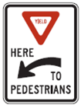

INSTRUCTOR INITIALS __________ PARENT/GUARDIAN INITIALS __________
BTW 10
DRIVING ON MULTI-LANE STREETS

OBJECTIVE: The student will be able to manage space, time and visibility while driving on urban streets. The student will be aware of specific dangers while driving in heavy traffic.

SKILLS FOR MANAGING VISIBILITY
- Search 1-2 blocks ahead and side to side
- Get in the habit of using your rear view mirror and side mirrors
- Signal your intentions well ahead of time

SKILLS FOR MANAGING TIME
- Driving at a moderate speed
- Using the Find-Solve-Control System
- Being a defensive driver by covering your brake in situations you are not comfortable

SKILLS FOR MANAGING SPACE
- Proper following distance (3-4 seconds)
- Proper stopping position (10-20 ft. behind the vehicle in front of you)

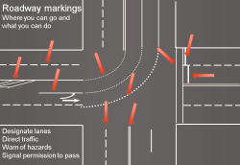

INSTRUCTOR INITIALS __________ PARENT/GUARDIAN INITIALS _________
BTW 11
PRACTICE FINAL DRIVE
OBJECTIVE: The student will be able to negotiate themselves around rural and urban streets without any verbal cue. They will, however, be given directions. The student will demonstrate knowledge of traffic rules and regulations. The student will be able to perform basic driving tasks lawfully, correctly, and safely.

In this lesson, the student will perform a practice test drive on streets where they are likely to be tested by a Driver Examiner for their driver license.

The student will be tested on:
- Driving preparation
- Starting the vehicle
- Numerous right and left turns
- Sign recognition
- Driving attitude and habits
- Parallel parking
- Intersections
- One-way streets
- Securing the vehicle

AREAS NEEDING IMPROVEMENT AND EXTRA PRACTICE:

INSTRUCTOR INITIALS __________ PARENT/GUARDIAN INITIALS __________
BTW 12
FINAL DRIVE

OBJECTIVE: This final drive repeats the practice final drive in BTW 11 with the same objective, to demonstrate knowledge and skill in all the areas that are required to be a safe and competent driver and pass the road test. This final drive will be tested and given a score to determine if the road test can be waived when the teen applies for their restricted driver license at the Department of Motor Vehicles exam station after the required 50 hours and six months of supervised practice.

If the student does not pass this test, they will be required to take it again from the driver examiner when they apply for their restricted driver license.
You may still be asked to drive again and take the road test even if you passed the test during Driver Education. The MVD re-tests 10% of the class to make sure the instructor is doing their job. Please don’t be offended if you are asked to drive. The 10% are chosen randomly.

Practice, practice, practice. This is essential for new drivers. Stay calm and expect mistakes. The more you drive with your parent or guardian, the more skills you will have behind-the-wheel. Supervised driving practice in varied weather, traffic and road conditions greatly increases your chances for success. It also contributes to more confidence, smart judgment, and safe choices like always wearing your seat belt, driving unimpaired, and with few distractions.

The Graduated Driver License (GDL) law requires teens with learner licenses to drive with a parent, guardian or licensed adult driver authorized by the parent/guardian for a minimum of 50 hours (10 at night) over a minimum of six months BEFORE they can apply for their restricted license.
INSTRUCTOR INITIALS __________ PARENT/GUARDIAN INITIALS __________
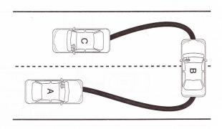
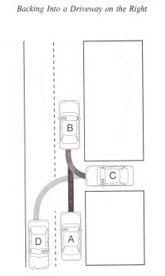
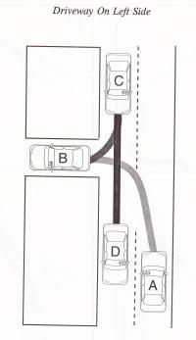
Maneuvers
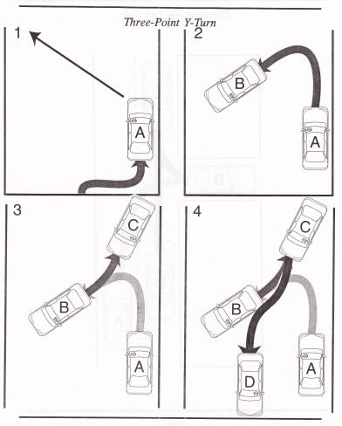
GETTING YOUR RESTRICTED LICENSE
After you’ve driven at least 50 hours with your parent or guardian for a minimum of six months, you can apply for your solo driver license. Many driver exam stations allow you to make an appointment to get your GDL restricted license. Visit https://dojmt.gov/driving/appointment-scheduling/ or call the MVD Customer Care Center at (866) 450-8034 to schedule your appointment.

YOU NEED TO BRING:
- A certified copy of your birth certificate
- Your Social Security card or number
- Proof of Montana residency (a piece of mail or a document with your legal name and Montana physical address)
- Your parent or guardian to sign for you and verify you have NO alcohol, drug or traffic violations
- Your glasses or contacts if you wear them (for your eye exam)
- Your Practice Driving Log to show your 50 hours

WHY A “RESTRICTED” LICENSE?
Your highest lifetime crash risk is in your first months of independent driving due to inexperience, speed and driver errors.
Night-Driving Restriction: Darkness increases crash risk. Teens may not drive between 11:00 p.m. and 5:00 a.m. Limited exceptions may apply. As a young driver, your greatest risk of being involved in a fatal or injury crash is at night.
Passenger Restriction: Teens need time to become familiar with driving without adult or other passengers. The risk of a fatal crash for a teen driver doubles with just one teen passenger. Each new passenger increases the risk of a fatal crash.
- One passenger - For the first six months teens may drive with only one passenger who is not a family member.
- Up to three passengers - For the second six months teens may drive with up to three passengers who are not family members.

COMPLETED DRIVES

1. ____CAR INTRO 1
2. ____CAR INTRO 2
3. ____PARKING/BACKING
4. ____ONE WAYS/LANE CHANGES 1
5. ____ONE WAYS/LANE CHANGES 2
6. ____RURAL DRIVING
7. ____INTERSTATE DRIVING
8. ____PARALLEL PARKING
9. ____DOWNTOWN DRIVING
10. ____URBAN DRIVING
11. ____PRACTICE FINAL DRIVE
12. ____FINAL DRIVE

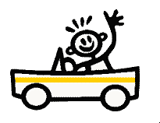
Developed by Jerry Olson, Driver Instructor, Great Falls, Montana

